Command w,who,whoami

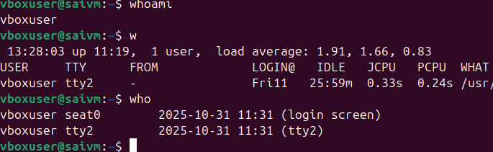

**Command: ls**

Description: Lists files and directories in the current directory.

Example: ls will display files and folders in your current directory, and ls -l provides detailed information

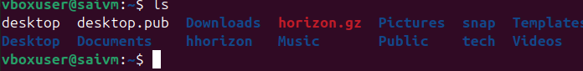

**Command: ip a**

Description: Lists your IP address and network interfaces.

Example: ip a shows all network interfaces and their IP addresses

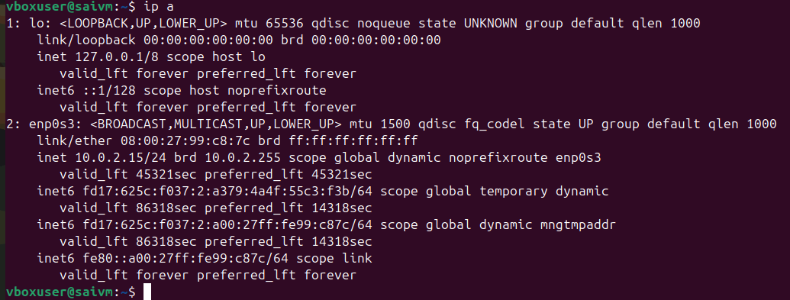

**Command: cat**

Description: Reads the contents of text files.

Example: cat myfile.txt will display the content of myfile.txt

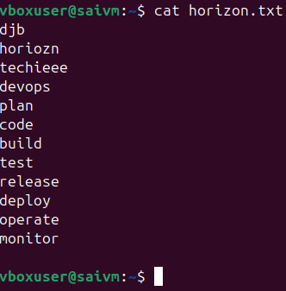

**Command: passwd**

Description: Used to change the password of the user account.

Example: Typing passwd and following the prompts will allow you to change your password

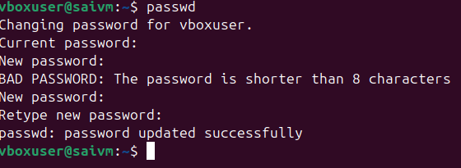

**Command: touch**

Description: Creates empty files, mainly useful to test write ability.

Example: touch newfile.txt creates an empty file named newfile.txt.

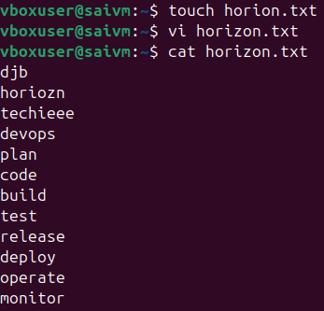

**Command: pwd**

Description: Stands for Print Working Directory; shows which directory you are in.

Example: Running pwd might return /home/john_doe.

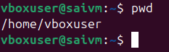

**Command: man**

Description: Accesses the system documentation for commands.

Example: man ls will show the manual for the ls command

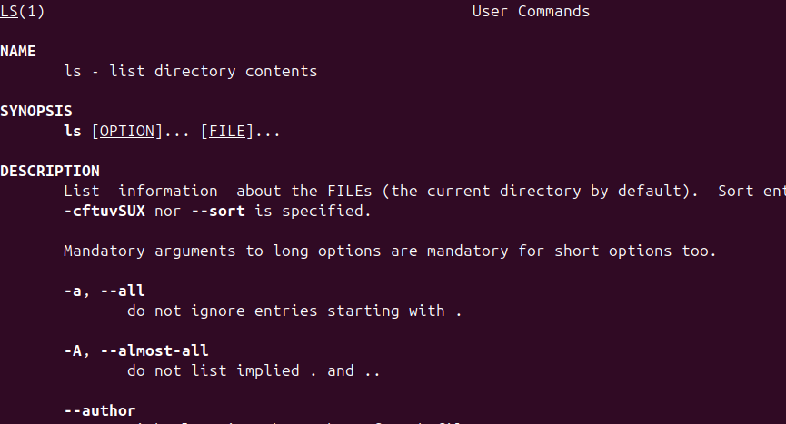

**Command: apropos**

Description: Searches commands related to a specific task based on description (equivalent to man -k).

Example: apropos "list files" might return commands related to listing files

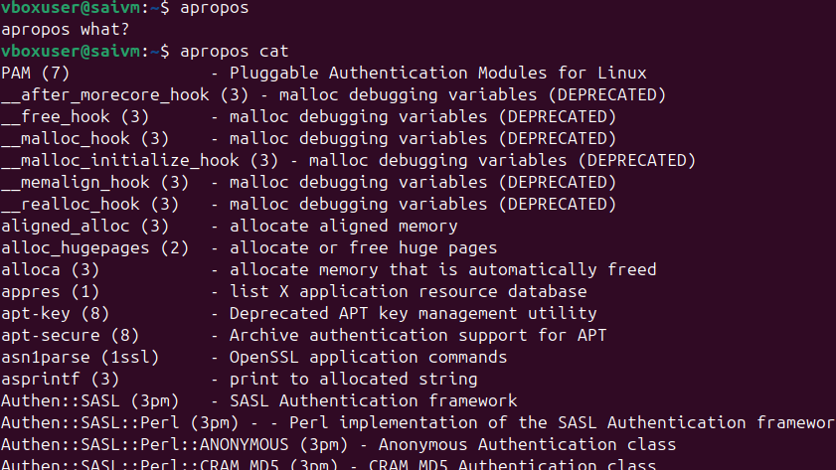

**Command: pinfo**

Description: Provides additional information, similar to man.

Example: pinfo ls gives detailed information about the ls command

Command : pinfo pinfo

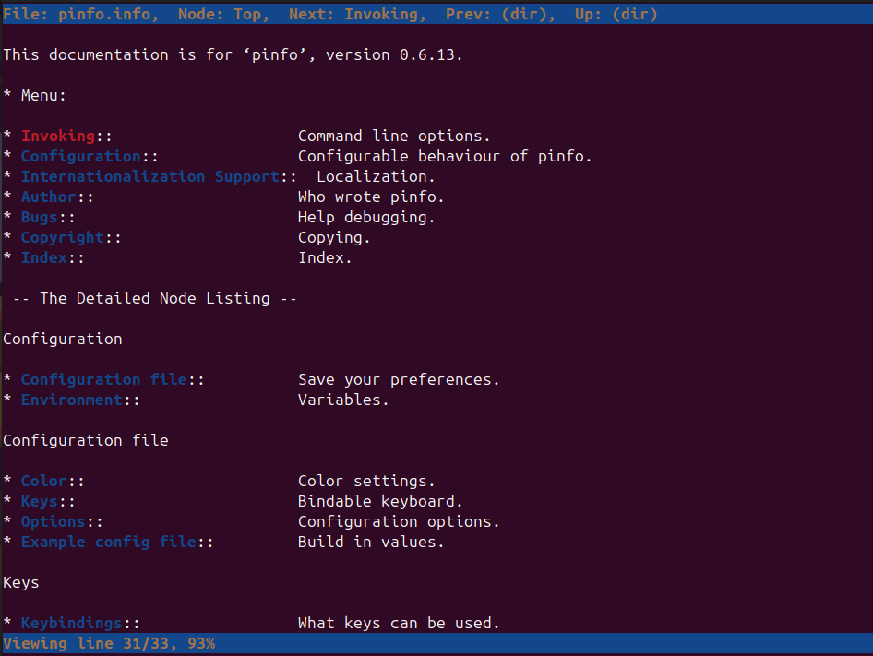

Pinfo ls

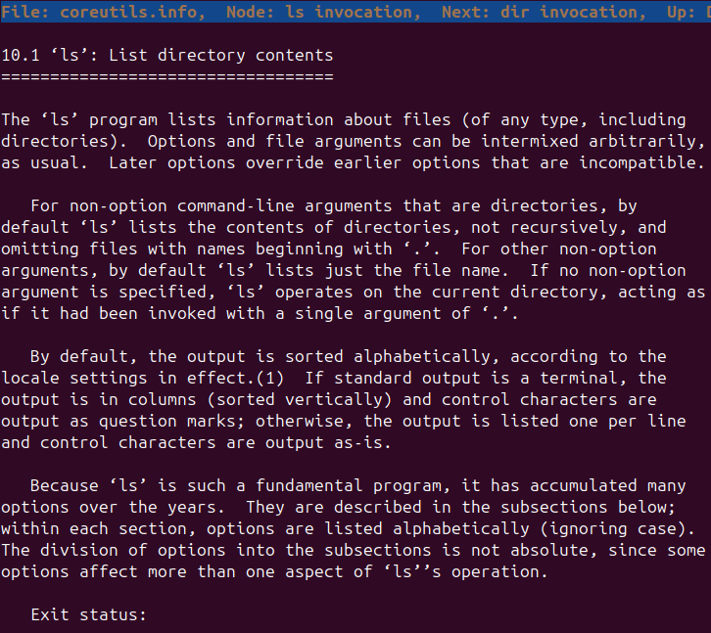

**Essential File Management Tools Commands**

**Command: ls**

Example: ls /home/user/Documents

Description: Lists files and directories within a specified path. This command is used to view the contents of directories

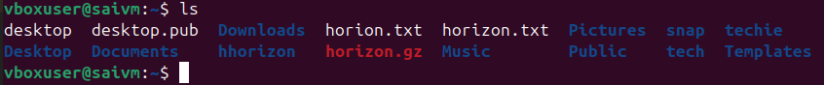

**Command: cp**

Example: cp source.txt destination.txt

Description: Copies files from one location to another. This command is used to make duplicates of files

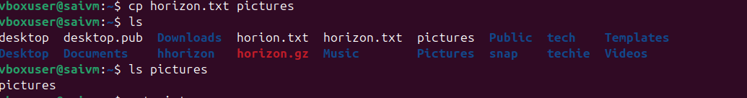

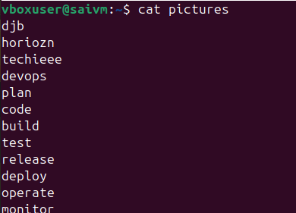

**Command: mkdir**

Example: mkdir new_directory

Description: Creates a new directory. This command is used when you need to make a new folder

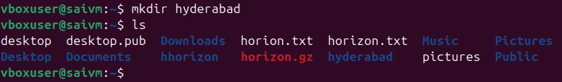

**Command: rmdir**

Example: rmdir empty_directory

Description: Removes a directory, but only if it's empty. This command is used for deleting empty folders

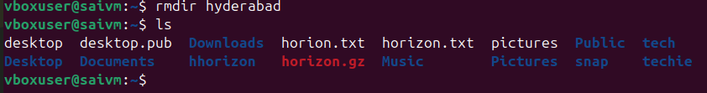

**Command: mv**

Example: mv oldname.txt newname.txt

Description: Moves or renames files and directories. This command can change the location or the name of a file.

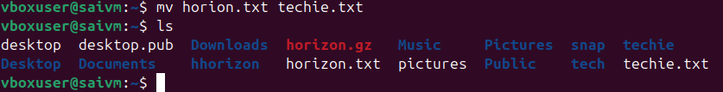

**Command: rm**

Example: rm filename.txt

Description: Removes files or directories. This command deletes files or directories.

Note: When combined with options -r (recursive) and -f (force), as in rm -rf directory_name, it becomes a powerful command that can delete directories and their contents without asking for confirmation



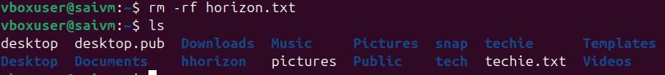

**Advanced File Management Tools Commands**

**ln**: Used for creating hard and symbolic links.

Example: ln -s source_file symbolic_link creates a symbolic link to source_file.

Description: Links a file or directory to another location

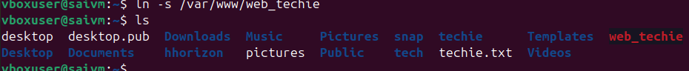

hard link

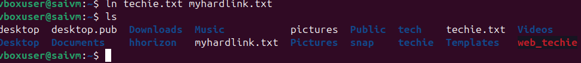

**find**: A utility to find files based on various properties.

Example: find /home -name "*.txt"searches for text files in the /home directory.

Description: Searches for files and directories in a given path

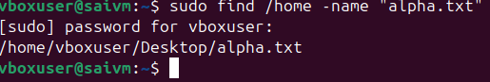

For searching files with .txt

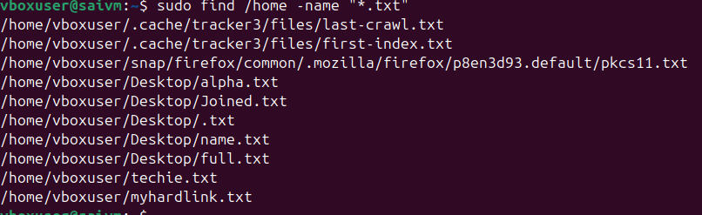

Files older than 7days

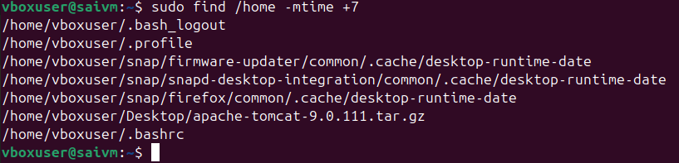

**locate**: Used for quickly searching the database of system's contents.

Example: locate filename finds the location of filename.

Description: Fast file searching, requires running updatedb for an updated database

We can use locate filename



**which**: Finds the location of executables in the PATH.

Example: which python shows the path of the Python executable.

Description: Useful for finding executable files in system's PATH

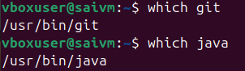



**tar**: Archives multiple files into a single file.

Example: tar -cvf archive.tar /foldercreates an archive of a folder.

Description: Combines multiple files into a tarball.

It stands for **“tape archive”**, and it’s one of the most common tools for **compressing and backing up files**.

• c → create a new archive x → Xtrat the archive

• v → verbose (show progress)

• f → file name of the archive

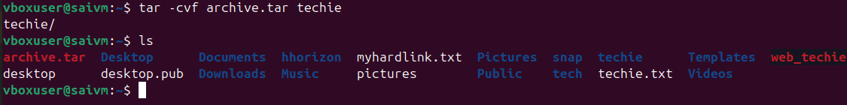

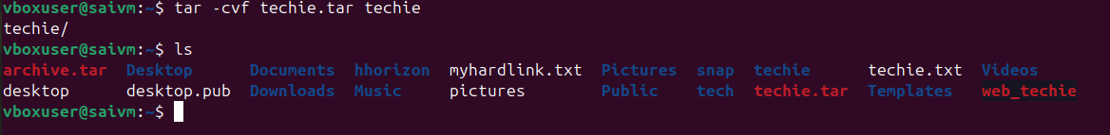

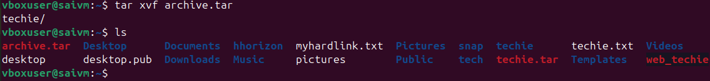

**gzip** : Compresses files.

Example: gzip file.txt compresses file.txt.

Description: Reduces the size of files using compression



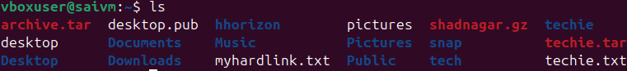

**bzip2**: A file compression utility.

Example: bzip2 file.txt compresses file.txt.

Description: Offers better compression ratios than gzip at the cost of speed

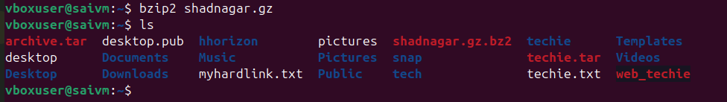

**xz**: High compression utility.

Example: xz file.txt compresses file.txt.

Description: Provides the best compression ratio.

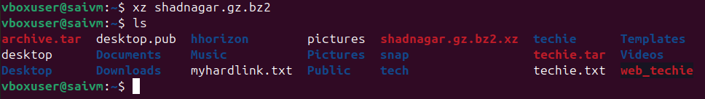

**zip**: Used for packaging and compressing (archiving) files.

Example: zip archive.zip file1 file2 creates an archive with file1 and file2.

Description: Commonly used for creating .zip files.

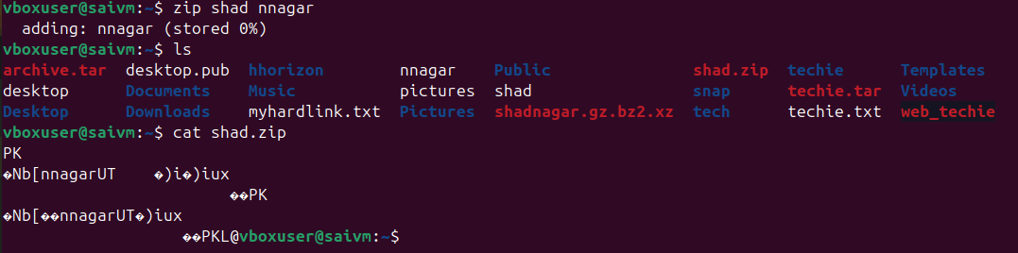

**file**: Determines the type of a file.

Example: file image.jpg displays the type of image.jpg.

Description: Useful for identifying file formats

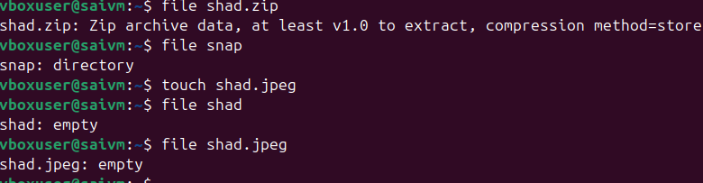

**mount**: Attaches a filesystem to a specified directory.

Example: mount /dev/sdb1 /mnt mounts the device sdb1 to /mnt.

Description: Used to access filesystems on different storage devices

**df**: Displays disk space usage of all mounted filesystems.

Example: df -h shows disk space in human-readable format.

Description: Useful for monitoring disk space usage.

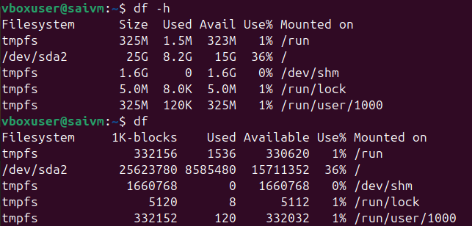

**findmnt**: Lists all mounted filesystems.

Example: findmnt -t ext4 lists all ext4 type mounts.

Description: Displays a tree-like structure of mounts

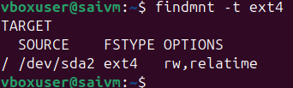

**lsblk**: Lists information about block devices.

Example: lsblk lists all block devices.

Description: Useful for identifying storage devices and their partitions

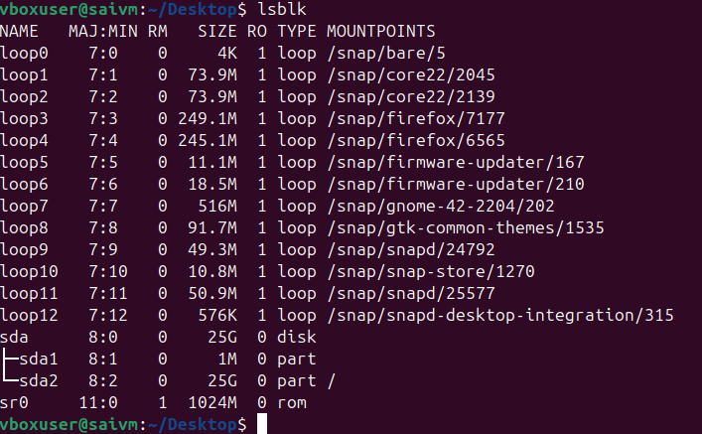

**Working with Text Files Commands**

**Command : nano**

Description: A user-friendly text editor.

Example: nano filename.txt - Opens filename.txt in nano editor.

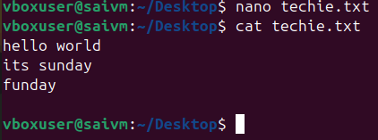

**vimtutor**

Description: A tutorial program for learning VIM, an advanced text editor.

Example: vimtutor - Starts the VIM tutorial.

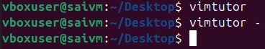

**vi**

Description: The original text editor, with basic features.

Example: vi filename.txt - Opens filename.txt in VI editor

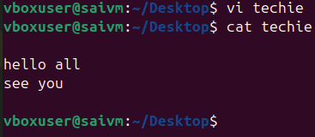

**vim**

Description: An improved version of VI with more features.

Example: vim filename.txt - Opens filename.txt in VIM editor.

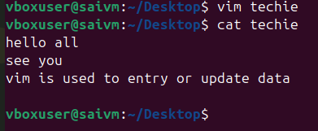

**more**

Description: A pager to view the contents of text files, one screen at a time.

Example: more filename.txt - Views the content of filename.txt.

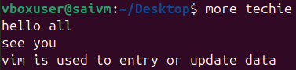

**less**

Description: Similar to more, but provides more control over viewing text files.

Example: less filename.txt - Opens filename.txt for viewing with navigation options



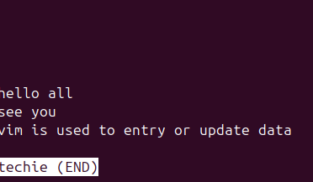

**head**

Description: Displays the first few lines of a text file.

Example: head filename.txt - Shows the top lines of filename.txt.

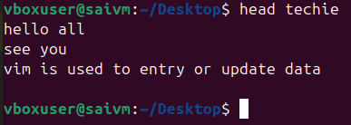

**tail**

Description: Displays the last few lines of a text file.

Example: tail filename.txt - Shows the last lines of filename.txt

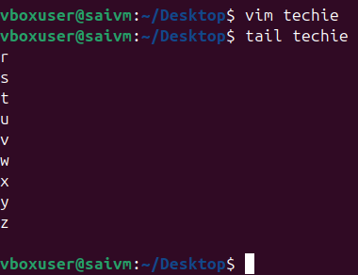

**cat**

Description: Concatenates and displays the entire content of text files.

Example: cat filename.txt - Displays the full content of filename.txt.

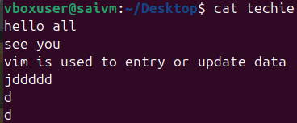

**cat -A**

Description: Similar to cat, but also displays special characters.

Example: cat -A filename.txt - Shows the content of filename.txt, including special characters

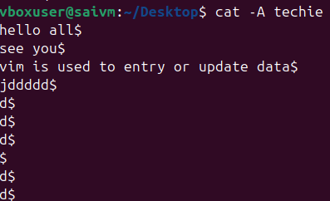

**tac**

Description: Prints the contents of a text file in reverse order.

Example: tac filename.txt - Displays filename.txt content backwards

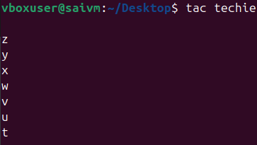

**grep**

Description: Searches for text in files or command output.

Example: grep 'pattern' filename.txt- Searches for 'pattern' in filename.txt

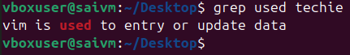

**grep**:

Command: "grep"

Example: grep 'pattern' file.txt

Description: Filters text in files by searching for specific patterns.



**awk**:

Command: "awk"

Example: "awk '/pattern/ {print}' file.txt"

Description: Filters and processes text, with additional features for text manipulation

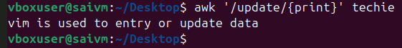

**sed**:

Command: "sed"

Example: "sed 's/old/new/' file.txt"

Description: A stream editor used for modifying text files directly from the command line

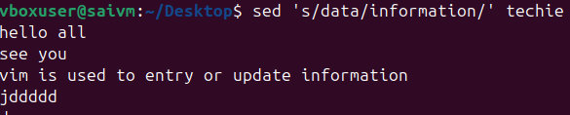

Command: "tr"

Example: "tr '[:lower:]' '[:upper:]' < file.txt"

Description: Translates or deletes characters from input text

• tr → translate or replace characters

• '[:lower:]' → all lowercase letters

• '[:upper:]' → all uppercase letters

• < inputfile → take input from a file

• > techie → save output to a new file



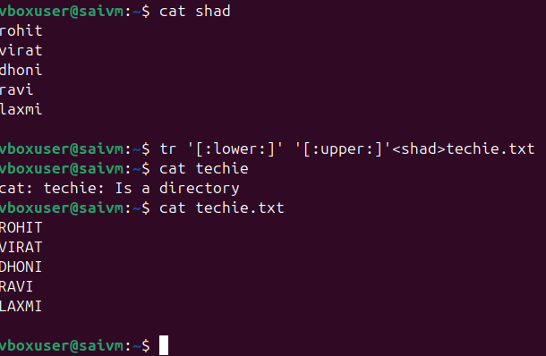

**cut**:

Command: "cut"

Example: "cut -d':' -f1 file.txt"

Description: Extracts sections from each line of files, such as columns from a table

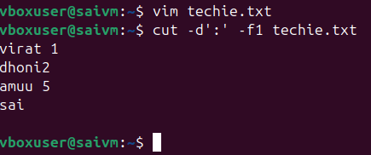

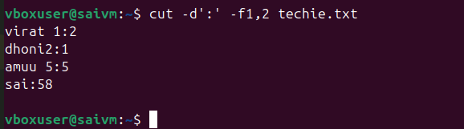

**sort**:

Command: "sort"

Example: "sort file.txt"

Description: Sorts text files in alphabetical or numerical order, as specified.

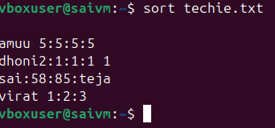

**Connecting to a Server Commands**

**su Command**

Example: su username

Description: This command is used to switch user identity in a Unix-like operating system. When you type su followed by a username, it prompts you for the password of that user and, if entered correctly, logs you in as that user.

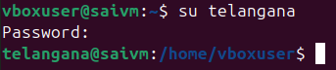

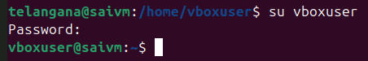

**sudo Command**

Example: sudo apt update

Description: The sudo command allows a permitted user to execute a command as the superuser or another user, as specified in the sudoers file. This example updates the list of available packages and their versions, but it requires administrative privileges, hence the use of sudo.

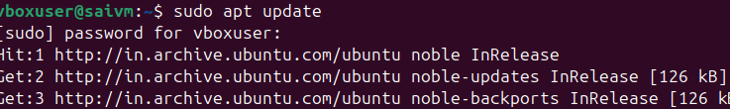

**ssh Command**

Example: ssh username@hostname

Description: ssh stands for Secure Shell. It's used to connect and log into a remote machine securely. The example shows how to connect to a remote host where username is your username on the remote machine, and hostname is the address of the remote machine.

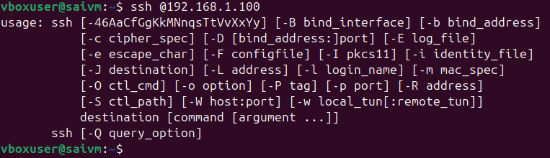

**scp Command**

Example: scp file.txt username@hostname:/path/to/destination

Description: The scp command is used for secure copy from one machine to another. In the example, file.txt is being copied to a remote host. The username@hostname specifies the user and host of the remote machine, and /path/to/destinationis where the file will be placed on the remote machine

Ex: scp file.txt user@remote_host:/remote/directory/

**Working with the Bash Shell commands**

**tee**

Example: ls | tee file.txt

Description: Used in pipes to direct the output of a command both to a file and the next command in the pipe.



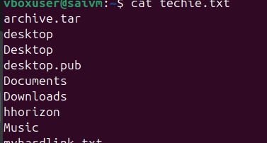

**history**

Example: history

Description: Displays a list of previously executed commands

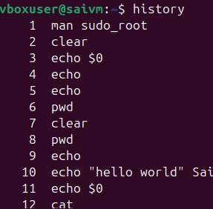

**history -d**

Example: history -d 1023

Description: Deletes a specific command from the history, where 1023 is the history entry number you want to remove.





Delete btwn numbers 1-n

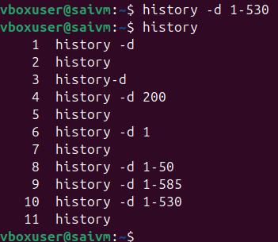

**alias**

Example: alias ll='ls -l'

Description: Creates a shortcut for a longer command. In this example, typing ll will execute ls -l.

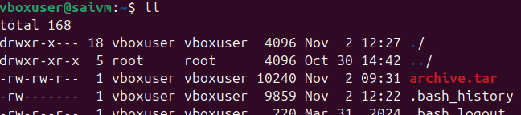

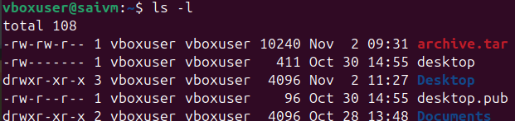

**export**

Example: export VAR=value

Description: Sets an environment variable VAR to a value value and makes it available to subshells

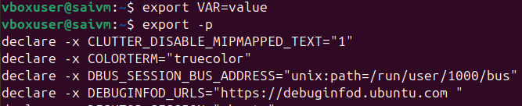

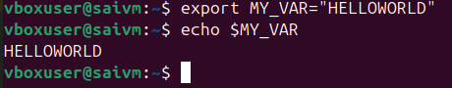

**User and Group Management and Permissions Commands**

**useradd: Adds users.**

Example: useradd johndoe

Description: Creates a new user account named 'johndoe'

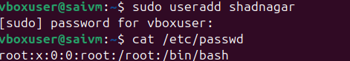

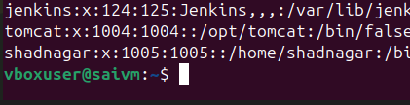

Use **useradd** if you want full control and are okay with manual steps. Use **adduser** if you want a quick, interactive way to add a user with default settings.

**usermod: Modifies user properties.**

Example: usermod -L johndoe

Description: Locks the user account 'johndoe'



To check status of the user passwd -S shadnagar



To unlock the user usermod -U shadnagar

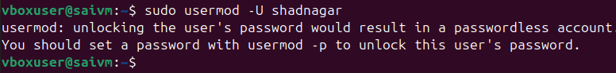

**userdel: Deletes users.**

Example: userdel johndoe

Description: Removes the user account 'johndoe'

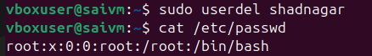

**💡 Summary:**

* 🧱 userdel → **Basic system tool** for removing users (works on all Linux).
* 🧩 deluser → **User-friendly wrapper** for Debian-based systems (Ubuntu, etc.).

**groupadd: Adds groups.**

Example: groupadd developers

Description: Creates a new group named 'developers'.

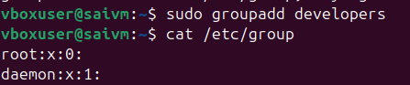



**groupmod: Modifies group properties.**

Example: groupmod -n newname oldname

Description: Renames a group from 'oldname' to 'newname'.

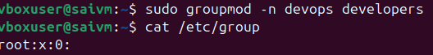

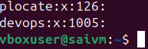

**groupdel: Deletes groups.**

Example: groupdel devops

Description: Removes the group named 'devops

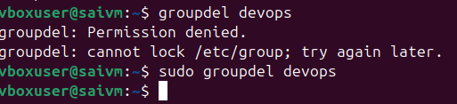

**id: Shows information about user accounts.**

Example: id johndoe

Description: Displays user and group IDs for 'johndoe'



**getent: Gets information from administrative databases.**

Example: getent passwd johndoe

Description: Retrieves user 'johndoe' details from the passwd database

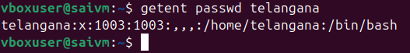

**passwd: Changes passwords.**

Example: passwd telangana

Description: Sets or changes the password for 'telangana'

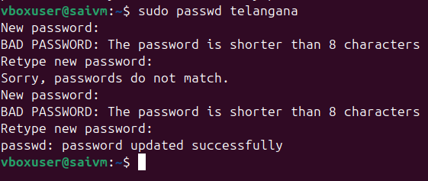

**chage: Modifies password properties.**

Example: chage -E 2023-12-31 johndoe

Description: Sets the expiry date of 'johndoe's password

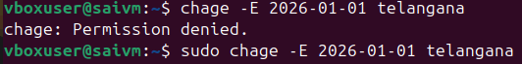

To view expiry date

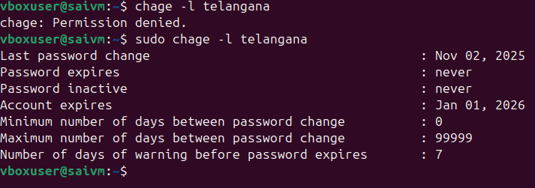

**w: Shows logged-in users and details.**

Example: w

Description: Lists users currently logged in with session details



**who: Shows currently logged-in users.**

Example: who

Description: Lists users currently logged in with minimal details

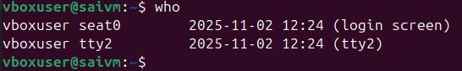

**vipw: Edits the passwd file.**

Example: vipw

Description: Opens the password file for editing

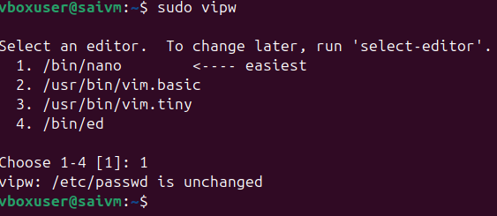

PASSWORD NOT CHANGED

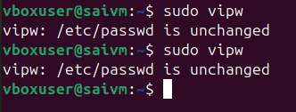

**vigr: Edits the /etc/group file.**

Example: vigr

Description: Opens the group file for editing

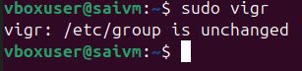

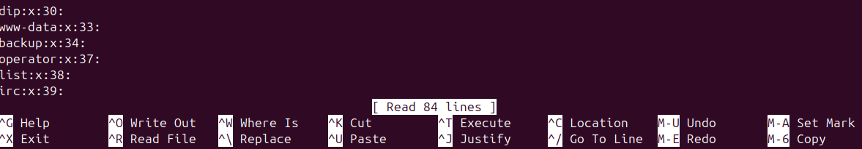

**loginctl: Manages user sessions.**

Example: loginctl list-sessions

Description: Lists current user sessions

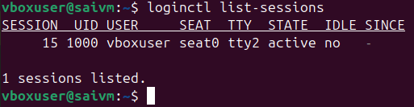

**Permissions Management commands**

**chown**

Example: chown user:group filename

Description: Changes the ownership of a file or directory. The command alters both user and group ownership. It's a versatile command that eliminates the need for chgrp in most cases

Change of directory



Change of group



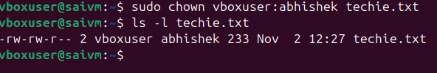

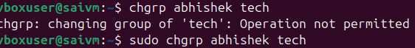

**chgrp**

Example: chgrp group filename

Description: Changes the group ownership of a file or directory. While this command is dedicated to changing group ownership, chown can also perform this function.

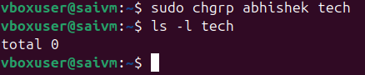

* Since ls -l shows **total 0**, it indicates that tech is a **directory** that contains **zero blocks** of data used by its contents (meaning it's empty).

**In summary, the commands successfully changed the group ownership of the directory tech to abhishek, and the directory tech is currently empty.**

**chmod**

Example: chmod 755 filename

Description: Changes the permission mode of a file or directory. It's an essential command for managing file and directory permissions in terms of read, write, and execute rights

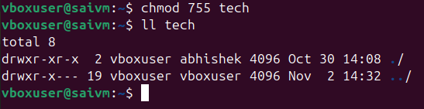

**diff**

Example: diff file1 file2

Description: Compares two files and displays the differences between them. This command is particularly useful in scenarios like checking changes in configuration files or script versions

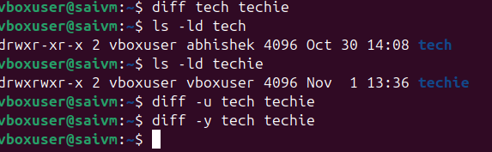

**find** (in the context of set user ID)

Example: find / -perm /4000

Description: Searches for files with set user ID permissions. This is important for security and system administration, to locate files that might have special privileges

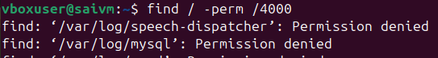

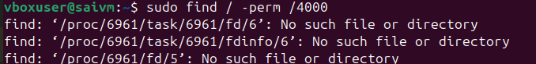

**umask**

Example: umask 022

Description: Sets the default permissions for newly created files and directories. It's a foundational command for establishing baseline security and access controls

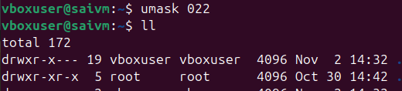

**Storage Management Essentials commands**

**lsblk**

Description: Lists all block devices.

Example: lsblk

This command displays information about all block devices connected to the system, such as hard drives and USB drives.

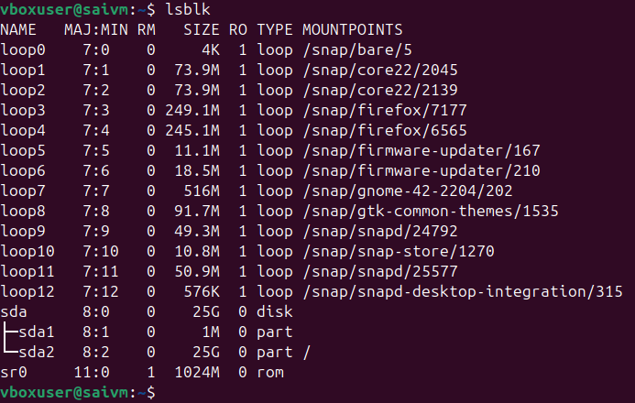

**fdisk**

Description: Manages partitions on an MBR disk.

Example: fdisk /dev/sda

Used for creating and managing disk partitions on an MBR (Master Boot Record) formatted disk

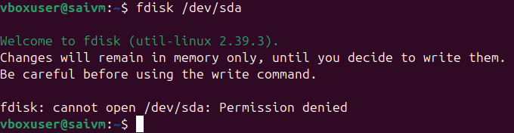

**gdisk**

Description: Manages partitions on a GPT disk.

Example: gdisk /dev/sda

Similar to fdisk but for GPT (GUID Partition Table) formatted disks, which are more modern

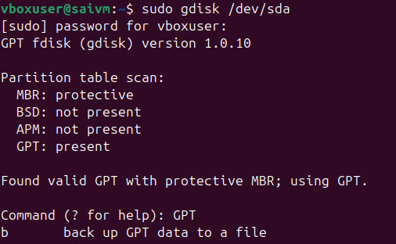

**mkfs**

Description: Creates a filesystem.

Example: mkfs.ext4 /dev/sda1

A generic utility to format a partition with a specific file system, such as ext4, xfs, or btrfs

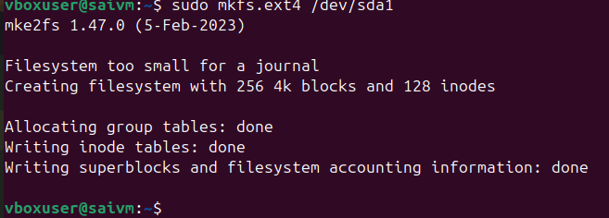

**mount**

Description: Attaches a filesystem to the file tree.

Example: mount /dev/sda1 /mnt

This command is used to mount a filesystem found on a device to a specific directory in the file tree.

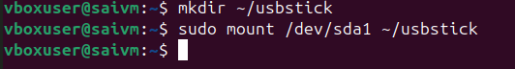

**findmnt**

Description: Lists mounted filesystems.

Example: findmnt

Provides a detailed overview of all the filesystems currently mounted in the system





**umount**

Description: Detaches the filesystem from the file tree.

Example: umount /mnt

Used to unmount a previously mounted filesystem

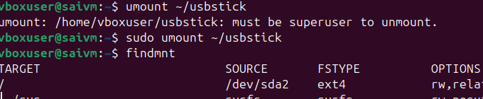

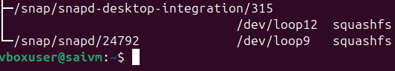

**Lsof "List Open Files**

Description: Lists open files and the processes using them.

Example: lsof /dev/sda1

Useful for diagnosing why a device might be busy, particularly if trying to unmount it and receiving a "device is busy" message

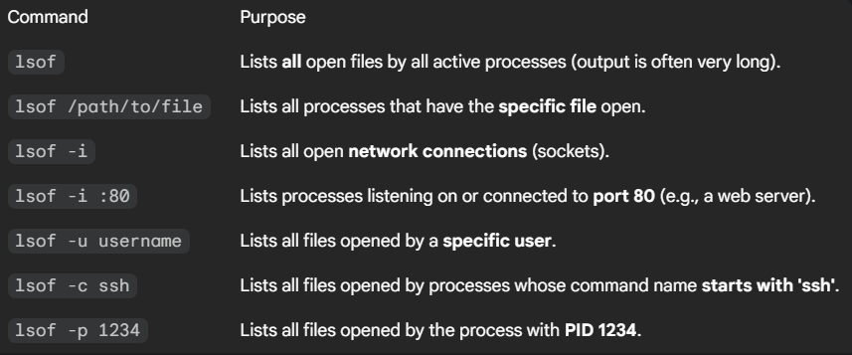

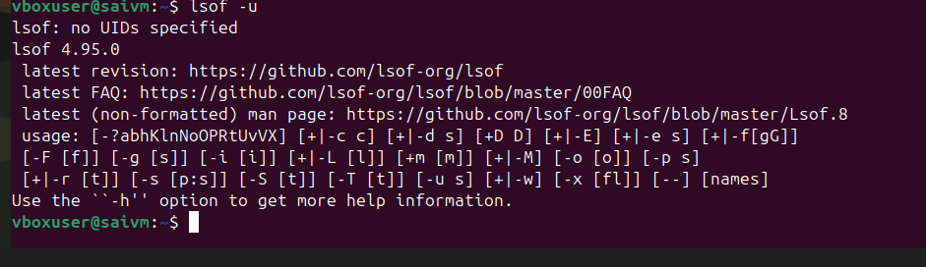

Command lsof -u username

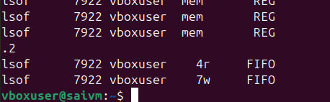

**Managing Networking commands**

**Command: ip a**

Example: ip a

Description: Prints current IP address information, showing the IP addresses assigned to all network interfaces.

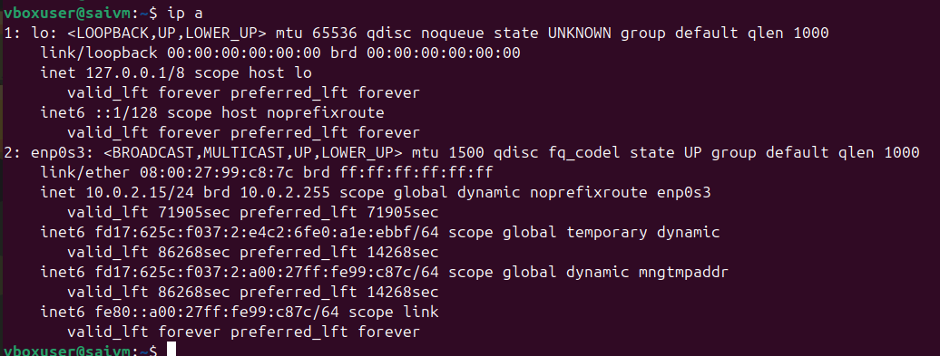

**Command: ip route show**

Example: ip route show

Description: Displays the routing table, including the default route, which is essential for understanding network routes.

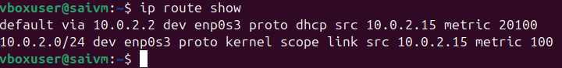

**command: ping**

Example: ping google.com

Description: Tests connectivity to a network host (e.g., a website like google.com) by sending ICMP packets

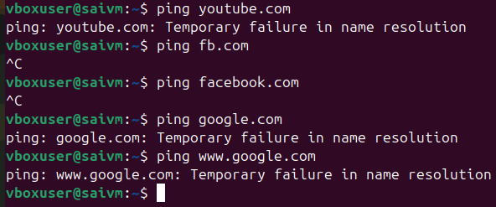

By using resolvectl status command we got some dns which are currently running

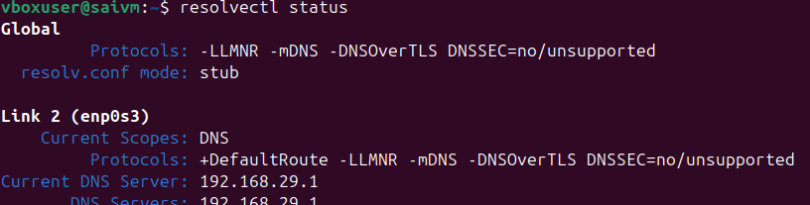

Then ping ipaddress



**Command: ss**

Example: ss -tuln

Description: Shows socket statistics. Used to check open ports and listening services on the system.

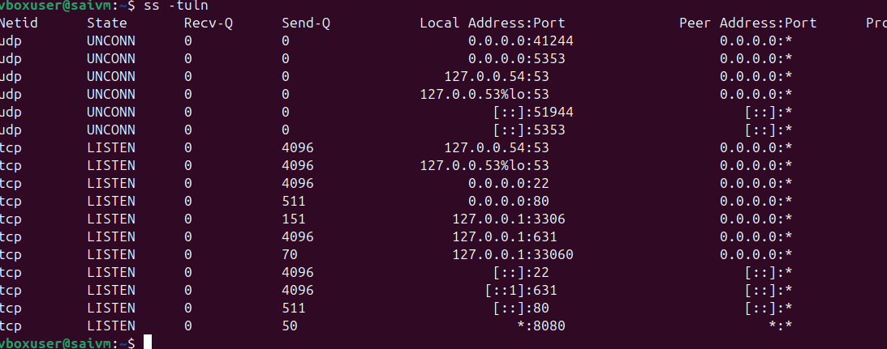

**Command: dig domain information groper**

Example: dig example.com

Description: Queries DNS information. It's useful for troubleshooting DNS issues or verifying DNS records.

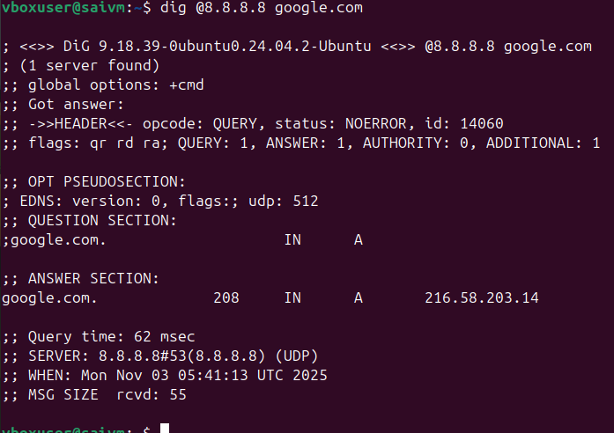

**Command: nmap**

Example: nmap -v 192.168.1.1

Description: An advanced security analysis tool that scans networks and systems for open ports, services, and other security vulnerabilities

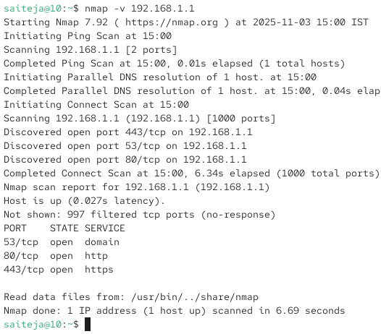

**Command: hostname**

Example: hostname

Description: Displays the system's host name.



**Command: hostnamectl**

Example: hostnamectl set-hostname myhostname

Description: Used for host name management, including viewing and changing the system's hostname.





**Working with Systemd commands**

**systemctl start or enable**

Example: systemctl start httpd

Description: Starts a specified unit file



**systemctl status**

Example: systemctl status httpd

Description: Displays the current status of a unit file

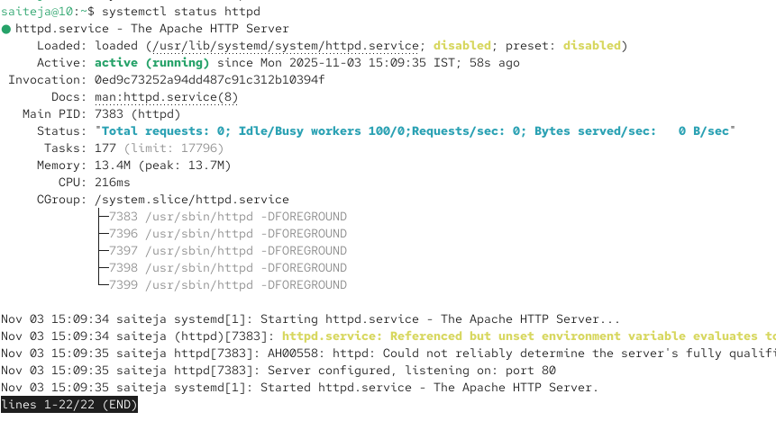

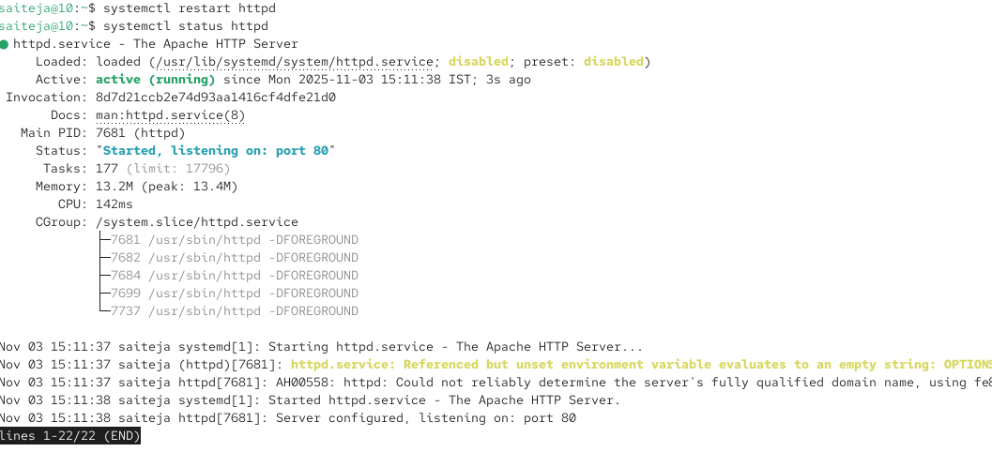

**systemctl stop**

Example: systemctl stop httpd

Description: Stops a running unit file

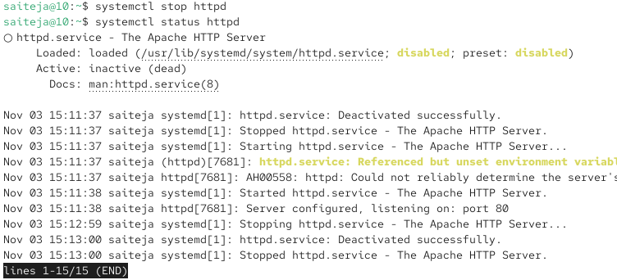

**systemctl enable**

Example: systemctl enable httpd

Description: Enables a unit file to start automatically on system boot and created sym link symbolic link



**systemctl disable**

Example: systemctl disable httpd

Description: Disables a unit file from starting automatically on boot and removes sym link



**systemctl list-units**

Example: systemctl list-units

Description: Lists all currently loaded unit files

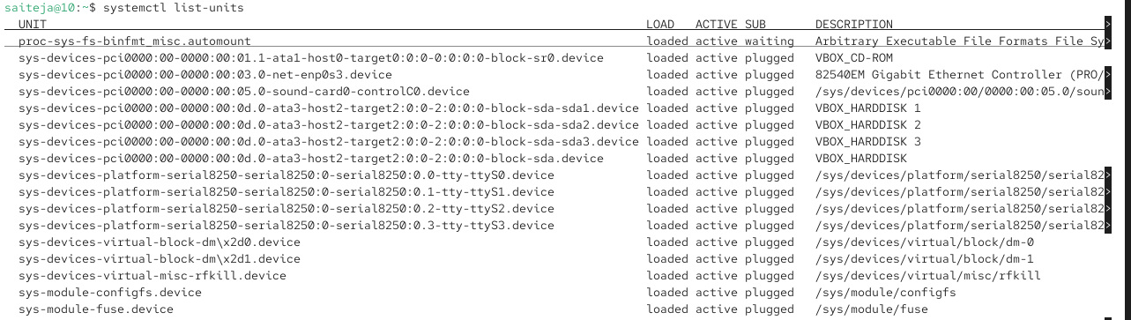

**systemctl set-default**

Example: systemctl set-default graphical.target

Description: Sets the default target that the system boots into



**systemctl get-default**

Example: systemctl get-default

Description: Displays the current default target

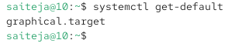

**systemctl cat**

Example: systemctl cat httpd

Description: Shows the configuration of a unit file

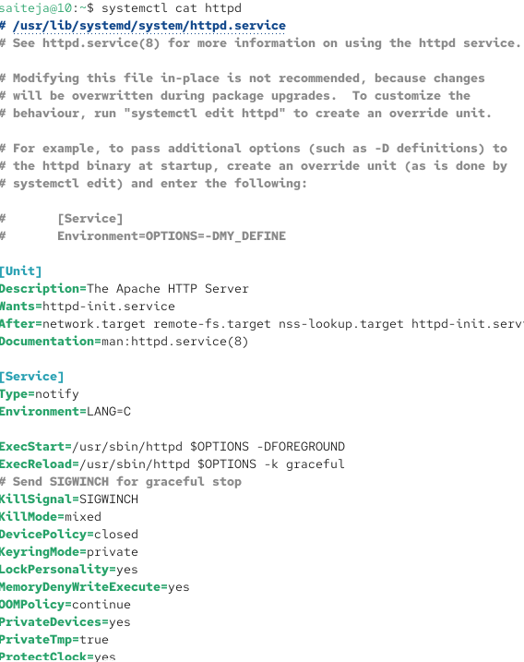

**systemctl show**

Example: systemctl show httpd

Description: Displays all the options set for a unit file

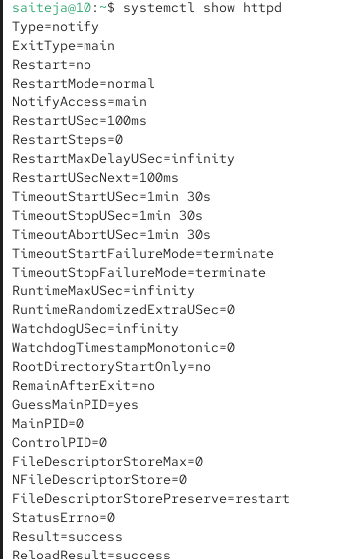

**systemctl edit**

Example: systemctl edit httpd

Description: Opens an editor to modify a unit file

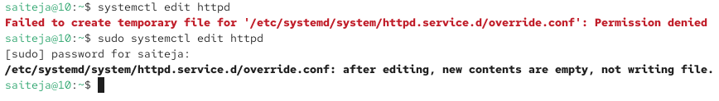

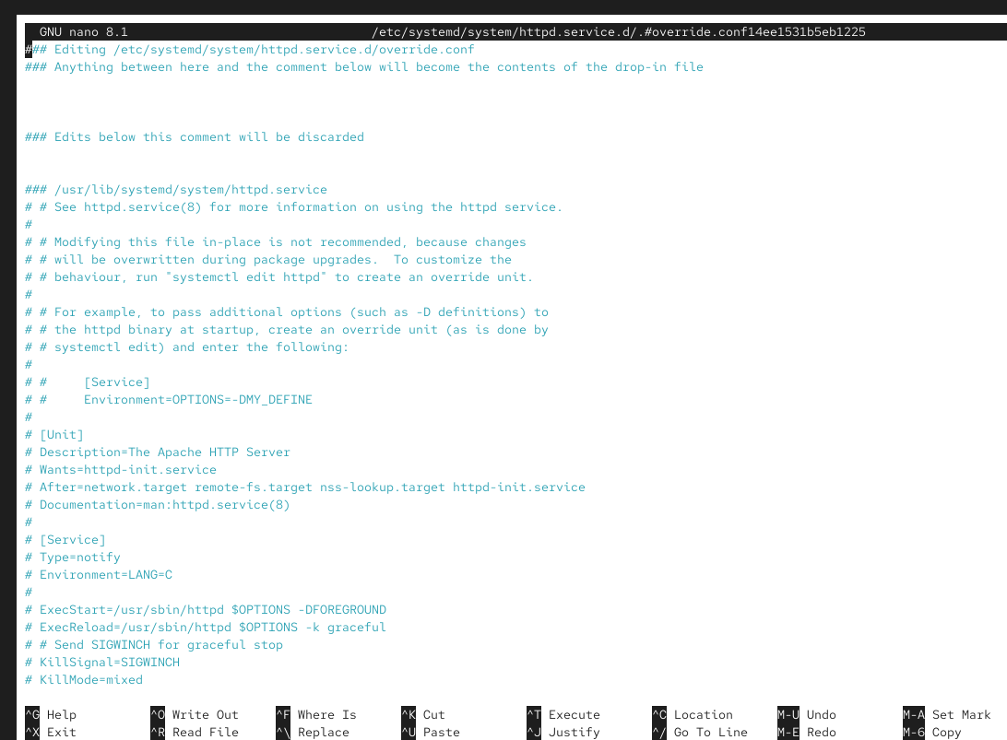

**systemctl daemon-reload**

Example: systemctl daemon-reload

Description: Instructs the systemctl main process to reload its configuration



**systemctl isolate**

Example: systemctl isolate graphical.target

Description: Switches the system to a different target



**systemctl list-dependencies**

Example: systemctl list-dependencies graphical.target

Description: Lists all dependencies of a specific target.

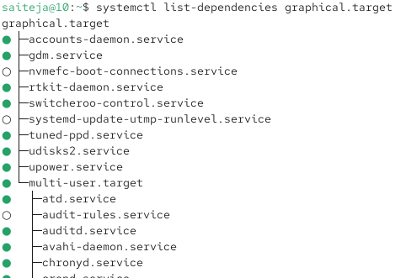

**Managing Software Commands**

**Command: rpm**

Description: Originally used for installing packages, rpm is now mainly used for querying information about installed packages.

Example: rpm -q package_name - This command queries details about a specific package

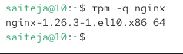

**Command: yum**

Description: yum is a software package manager used in Red Hat-based environments for installing, updating, and managing packages.

Example: yum install package_name - This command installs a specific package

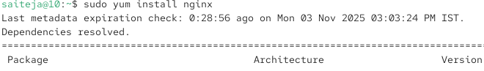

**Command: dnf**

Description: Similar to yum, dnf is a modern package manager for Red Hat-based systems, offering improved performance and package management capabilities.

Example: dnf update - This command updates all installed packages to their latest versions

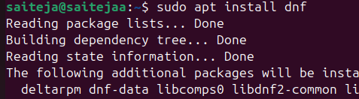



**Managing SSH Commands**

**Change SSH Port on Ubuntu:**

Command: **sudo vim /etc/ssh/sshd_config**

Description: Open the SSH configuration file using vim to change the SSH port



**Update SSH Port to 2022:**

: Change the line Port 22 to Port 2022 in the file.

Description: In the SSH configuration file, update the default port from 22 to 2022



**Restart SSH Service:**

Command: **sudo systemctl restart sshd**

Description: Restart the SSH daemon to apply the new configuration

**Managing Time commands**

**Command: date**

Example: date

Description: Displays the current date and time of the system. It's a basic and long-standing command in many operating systems.

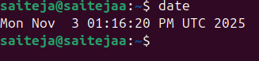

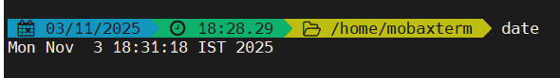

**Command: hwclock**

Example: hwclock --show

Description: Used for managing and viewing the hardware clock. It can also be used to synchronize the hardware clock with the system clock

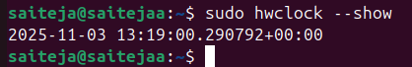

**Command: timedatectl**

Example: timedatectl status

Description: A modern utility for managing various aspects of time synchronization and settings. It can display and set time, date, and timezone, among other features

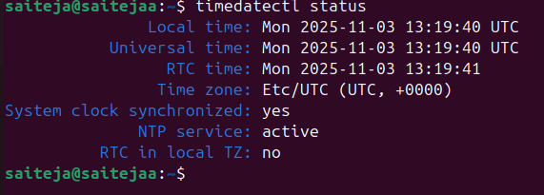

**Command: chronyc**

Example: chronyc tracking

Description: Interfaces with the chronyd time-synchronizing service, providing detailed information about the current synchronization status and more control over the chronyd service

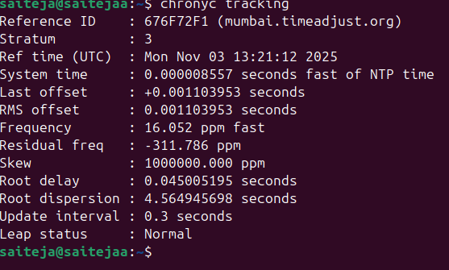

**Process Management Commands**

**Command: top**

Example: top

Description: Monitors all processes and the general health of the system from a performance perspective.

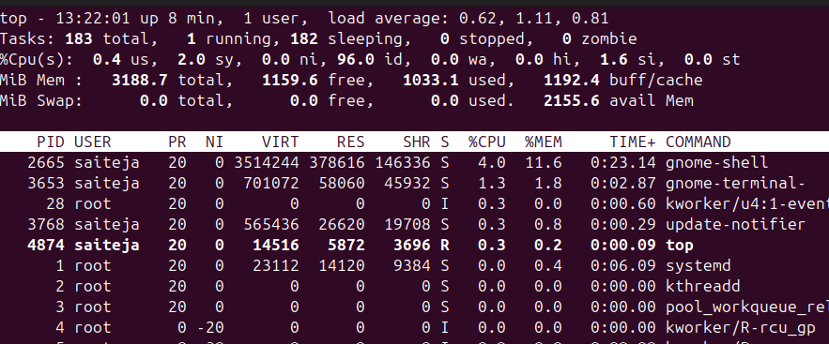

**Command: ps**

Example: ps aux

Description: Shows all processes and their properties; useful for monitoring system processes.

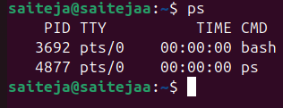

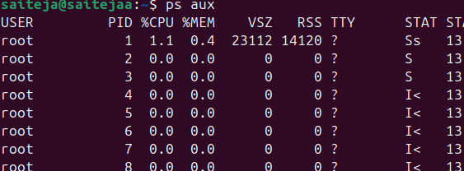

**Command: jobs**

Example: jobs

Description: Lists the jobs (processes) started by the user in the shell, allowing for management of interactive processes

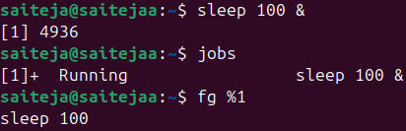

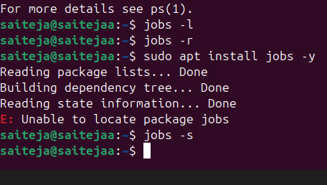

**Command: fg**

Example: fg %1

Description: Brings a job to the foreground, where %1 is the job number.



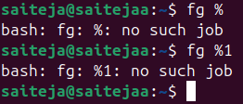

**Command: bg**

Example: bg %1

Description: Sends a job to run in the background



**Command: nice**

Example: nice -n 10 command

Description: Starts a process with a defined niceness (priority), where command is the command to be run with a priority.



Creating a bigfile of size 500 mb

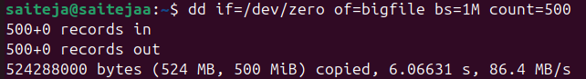

Run the command normally

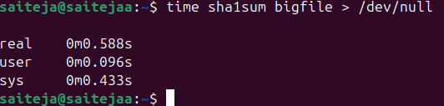

Run the same command with a *lower priority*

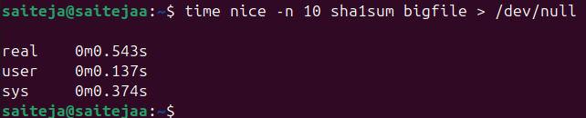

**Check its niceness while running**

In another terminal, run



Removing file

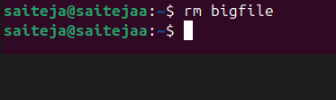

**Command: renice**

Example: renice -n 10 -p 1234

Description: Changes the priority of an already running process, where 1234 is the Process ID (PID).

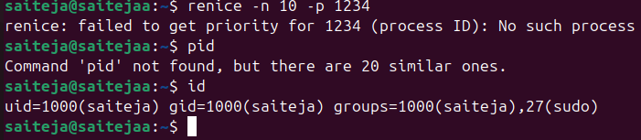

**Command: killall**

* + Example: killall processname

Description: Terminates all processes with the given name

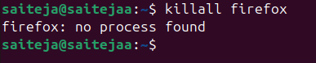

##### Scheduling Tasks Commands

**at Command**

Description: Allows you to schedule a job to run at a specific time.

Example: at 10:30 schedules a job to run at 10:30.

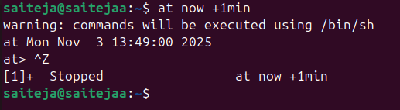

**atq Command**

Description: Displays a list of all jobs currently scheduled.

Example: atq shows all scheduled jobs with their job numbers



**atrm Command**

Description: Used to remove scheduled jobs.

Example: atrm 5 removes the job with the job number 5

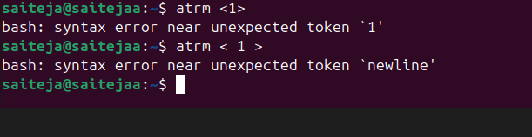

**Editing Cron Configuration with crontab -e**

Description: Opens the cron configuration for editing, allowing you to schedule jobs to run periodically.

Example: crontab -e opens the cron configuration file in a text editor.

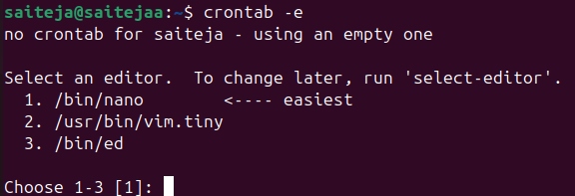

**Working with Systemctl Timers Using systemctl**

Description: Used to manage and interact with systemctl timers, a more systemwide approach for scheduling tasks.

Example: **systemctl list-timers** shows all active timers

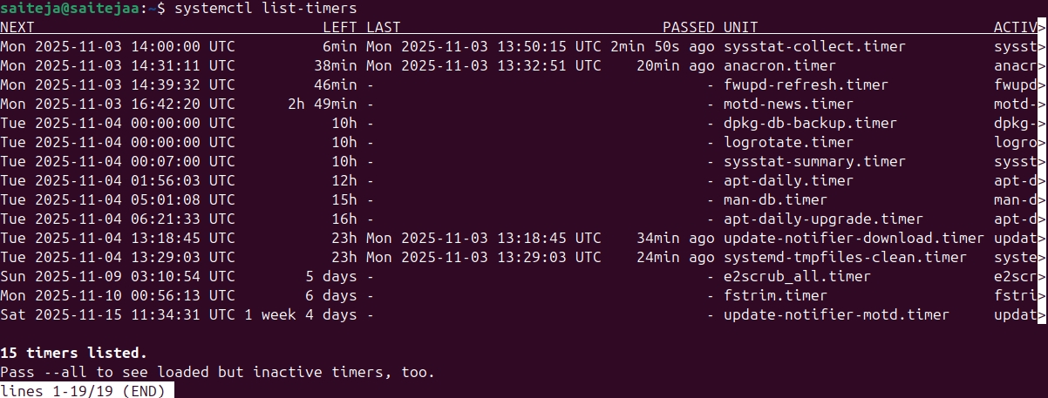

**Reading Log Files Commands**

**command: journalctl**

Description: This command is used to check the contents of the systemd journal, which is a centralized logging system for Linux.

Example: journalctl -u nginx.service

This example shows how to view logs for the Nginx service using journalctl

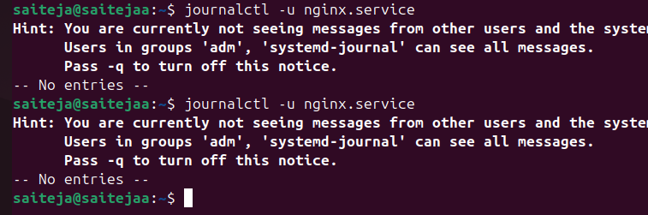

**Command: tail**

Description: The tail command is used to view the contents of log files, typically the last few lines.

Example: tail -n 100 /var/log/syslog

This example displays the last 100 lines of the syslog file

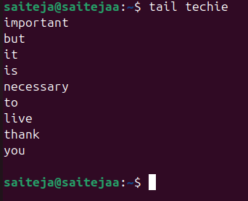

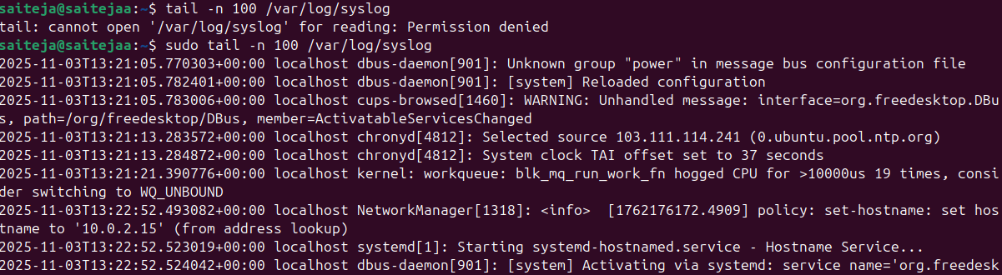

**Command: less**

Description: Similar to tail, less is used for viewing log files but allows for more controlled navigation through the file.

Example: less /var/log/apache2/access.log

This opens the Apache access log file in a scrollable interface for in-depth examination

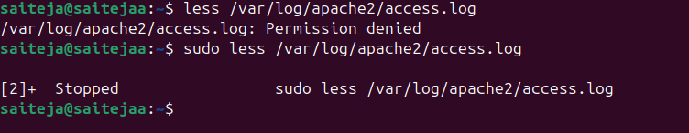

Adjust Firewall

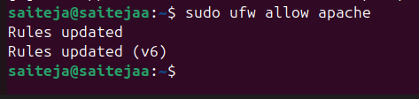

**Command: logger**

Description: The logger command is a convenient tool for writing messages to the system log.

Example: logger "System backup completed"

This example sends a custom message, "System backup completed," to the system log.

